**֍ WRITE A C++ PROGRAM TO CHECK WHEATHER A NUMBER IS PALINDROM OR NOT.**

PROGRAM CODE**:**

# include<iostream.h>

# include<conio.h>

int main()

{

int n,r,m,s=0;

cout<<"Entr a number:"<<endl;

cin>>n;

m=n;

while(n!=0)

{

r=n%10;

s=s*10+r;

n=n/10;

}

if(m==s)

cout<<"This number is palindrom";

else

cout<<"This number is not palindrom";

getch();

return(0);

}

OUTPUT:

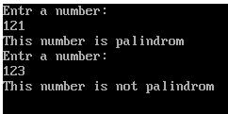

**֍ WRITE A C++ PROGRAM TO FIND FACTORIAL OF A GIVEN NUMBER USING RECURSION METHOD.**

PROGRAM CODE:

#include<iostream.h>

#include<conio.h>

long int fact(int);

int main()

{

int n;

clrscr();

cin>>n;

cout<<"Factorial of this number is:"<<fact(n);

getch();

return(0);

}

long int fact(int x)

{

if(x==0||x==1)

return(1);

else

return(x*fact(x-1));

}

OUTPUT:

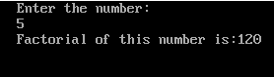

**֍ WRITE A C++ PROGRAM TO SORT NUMBERS IN ACCENDING ORDER USING SELECTION SORT.**

PROGRAM CODE:

#include<iostream.h>

#include<conio.h>

int main()

{

int a[20],i,j,n,temp;

clrscr();

cout<<"How many eliments:";

cin>>n;

cout<<"Enter array eliments:";

for(i=0;i<n;i++)

cin>>a[i];

for(i=0;i<n-1;i++)

for(j=i+1;j<n;j++)

if(a[i]>a[j])

{

temp=a[i];

a[i]=a[j];

a[j]=temp;

}

cout<<"After sorting by Selection Sort:";

for(i=0;i<n;i++)

cout<<" "<<a[i];

getch();

return(0);

}

OUTPUT:

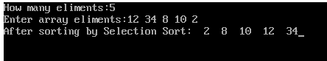

**֍ WRITE A C++ PROGRAM TO CONVERT A OCTAL NUMBER TO IT’S DECIMAL EQUEVALENT.**

PROGRAM CODE:

#include<iostream.h>

#include<conio.h>

#include<math.h>

int main()

{

clrscr();

double d=0,b=0;

int d1, r,i=0,j=0,n,p;

cout<<"Enter a octal number: ";

cin>>n;

while(n!=0)

{

r=n%10;

d=d+r*pow(8,i);

n=n/10;

i++;

}

d1=(int)d;

while(d1!=0)

{

p=d1%2;

b=b+p*pow(10,j);

d1=d1/2;

j++;

}

cout<<"The octal equevalent binary nuber is=

"<<b;

getch();

return(0);

}

OUTPUT:

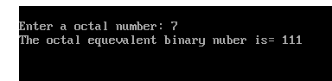

**֍ WRITE A C++ PROGRAM TO FIND THE MULTIPLICATION OF TWO MATRIX.**

PROGRAM CODE:

# include<iostream.h>

# include<conio.h>

int main()

{

int a[10][10],b[10][10],c[10][10],

i,j,k,arow,acol,brow,bcol;

clrscr();

cout<<"Enter the order of first matrix:";

cin>>arow>>acol;

cout<<"Enter the order of second matrix:";

cin>>brow>>bcol;

if(acol==brow)

{

cout<<"Enter the elements of first matrix";

for(i=0;i<arow;i++)

{

for(j=0;j<acol;j++)

{

cin>>a[i][j];

}

}

cout<<"Enter the elemnets of second matrix";

for(i=0;i<brow;i++)

{

for(j=0;j<bcol;j++)

{

cin>>b[i][j];

}

}

for(i=0;i<arow;i++)

{

for(j=0;j<bcol;j++)

{

c[i][j]=0;

for(k=0;k<acol;k++)

c[i][j]=c[i][j]+(a[i][k]*b[k][j]);

}

}

cout<<"The result matrix is"<<endl;

for(i=0;i<arow;i++)

{

for(j=0;j<bcol;j++)

{

cout<<c[i][j];

}

cout<<endl;

}

}

else

cout<<"Matrix multiplication is not possible";

getch();

return(0);

}

OUTPUT:

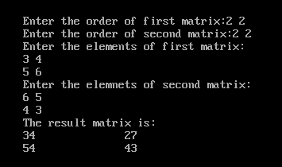

**֍ WRITE A C++ PROGRAM TO DEMONSTRATE FUNCTION OVERLOADING.**

PROGRAM CODE:

#include<iostream.h>

#include<conio.h>

float area (float r)

{

return(3.14*r*r);

}

int area (int l,int b)

{

return(l*b);

}

int main()

{

clrscr();

cout<<endl<<endl;

int x,y;

float r;

cout<<"Enter the redius of the circle"<<endl;

cin>>r;

cout<<"Enter the length and bredth of the

rectangle"<<endl;

cin>>x>>y;

cout<<"Area of the circle is:"<<area(r)<<endl;

cout<<"Area of the rectangle

is:"<<area(x,y)<<endl;

getch();

return(0);

}

OUTPUT:

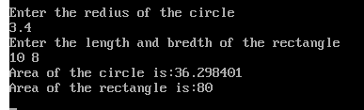

**֍ WRITE A C++ PROGRAM USING DEFAULT ARGUMENT.**

PROGRAM CODE:

#include<iostream.h>

#include<conio.h>

int main()

{

clrscr();

float amount;

float value(float p,int t,float r=1.5);

amount=value(5000.00,3);

cout<<"Total amount="<<amount;

getch();

return(0);

}

float value(float p,int t,float r)

{

float sum;

sum=(p*r*t)/100;

return(sum);

}

OUTPUT:

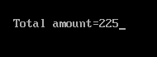

**֍ WRITE A C++ PROGRAM TO THROUGH OBJECT AS FUNCTION ARGUMENT.**

PROGRAM CODE:

#include<iostream.h>

#include<conio.h>

class time

{

int hour,min;

public:

void input(void);

void sum(time,time);

};

void time::input()

{

cout<<"enter hours"<<endl;

cin>>hour;

cout<<"enter the minutes"<<endl;

cin>>min;

}

void time::sum(time t1,time t2)

{

time t3;

t3.min=t1.min+t2.min;

t3.hour=t3.min/60;

t3.min=t3.min%60;

t3.hour=t3.hour+t1.hour+t2.hour;

cout<<"total time="<<t3.hour<<":"<<t3.min;

}

void main()

{

clrscr();

time t1,t2;

t1.input();

t2.input();

time t3;

t3.sum(t1,t2);

getch();

}

OUTPUT:

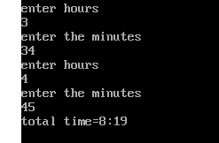

**֍ WRITE A C++ PROGRAM TO SHOW CONSTRUCTOR OVERLOADING.**

PROGRAM CODE:

#include<iostream.h>

#include<conio.h>

class add

{

int x;

int y;

public:

add()

{

x=0;

y=0;

}

add(int m,int n)

{

x=m;

y=n;

}

add(add &c)

{

x=c.x;

y=c.y;

}

void display()

{

cout<<"x="<<x<<endl;

cout<<"y="<<y<<endl;

}

};

void main()

{

clrscr();

add c1;

add c2(5,2);

add c3(c2);

cout<<"default:"<<endl;

c1.display();

cout<<"parametarized"<<endl;

c2.display();

cout<<"copy:"<<endl;

c3.display();

getch();

}

OUTPUT:

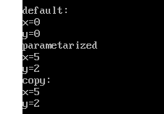

**֍ WRITE A C++ PROGRAM TO OVERLOAD MINUS(-) OPERATOR.**

PROGRAM CODE:

#include<iostream.h>

#include<conio.h>

class number

{

int a;

int b;

public:

number()

{

a=10;

b=20;

}

void operator-()

{

a=-a;

b=-b;

}

void display()

{

cout<<"value of a is"<<a<<endl;

cout<<"value of b is"<<b<<endl;

}

};

int main()

{

clrscr();

number obj;

obj.display();

cout<<"After operation the result is:"<<endl;

-obj;

obj.display();

getch();

return 0;

}

OUTPUT:

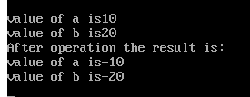

**֍ WRITE A C++ PROGRAM TO DEMONSTRATE MULTIPLE INHERITANCE.**

PROGRAM CODE:

#include<iostream.h>

#include<conio.h>

class student

{

int roll;

public:

void getroll()

{

cout<<"enter the roll number"<<endl;

cin>>roll;

}

void putroll()

{

cout<<"roll number ="<<roll<<endl;

}

};

class test

{

protected:

int m1,m2;

public:

void getmarks()

{

cout<<"enter your two subject marks"<<endl;

cin>>m1>>m2;

}

void putmarks()

{

cout<<"your 1st subject marks="<<m1<<endl;

cout<<"your 2nd subject marks="<<m2<<endl;

}

};

class result:public student,public test

{

int m3;

public:

void total()

{

m3=m1+m2;

cout<<"total result="<<m3<<endl;

}

};

void main()

{

clrscr();

result s1;

s1.getroll();

s1.getmarks();

s1.putroll();

s1.putmarks();

s1.total();

getch();

}

OUTPUT:

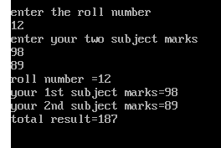

**֍ WRITE A C++ PROGRAM USING MULTILEVEL INHERITANCE DISPLAY STUDENT’S ROLL SUBJECT MARKS AND TOTAL MARKS.**

PROGRAM CODE:

#include<iostream.h>

#include<conio.h>

class student

{

int roll;

public:

void getroll()

{

cout<<"enter the roll number"<<endl;

cin>>roll;

}

void putroll()

{

cout<<"roll number ="<<roll<<endl;

}

};

class test:public student

{

protected:

int m1,m2;

public:

void getmarks()

{

cout<<"enter your two subject marks"<<endl;

cin>>m1>>m2;

}

void putmarks()

{

cout<<"your 1st subject marks="<<m1<<endl;

cout<<"your 2nd subject marks="<<m2<<endl;

}

};

class result:public test

{

int m3;

public:

void total()

{

m3=m1+m2;

cout<<"total result="<<m3<<endl;

}

};

void main()

{

clrscr();

result s1;

s1.getroll();

s1.getmarks();

s1.putroll();

s1.putmarks();

s1.total();

getch();

}

OUTPUT:

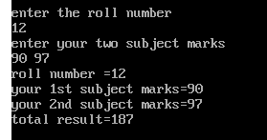

**֍ WRITE A C++ PROGRAM TO SWAP THE DATA ITEM OF TWO CLASS USING COMMON FRIEND FUNCTION.**

PROGRAM CODE:

#include<iostream.h>

#include<conio.h>

class b;

class a

{

int id;

public:

void getdata(int x)

{

id=x;

}

void display()

{

cout<<<”The value of x is:”<id<<endl;

}

friend void exchange(a&,b&);

};

class b

{

int id1;

public:

void getdata(int y)

{

id1=y;

}

void display()

{

cout<<”The value of y is:”<<id1<<endl;

}

friend void exchange(a&,b&);

};

void exchange(a&p,b&q)

{

int temp;

temp=p.id;

p.id=q.id1;

q.id1=temp;

}

void main()

{

clrscr();

a c1;

b c2;

c1.getdata(120);

c2.getdata(130);

cout<<"value before exchange:"<<endl;

c1.display();

c2.display();

exchange(c1,c2);

cout<<"value after exchange"<<endl;

c1.display();

c2.display();

getch();

}

OUTPUT:

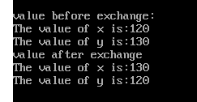

**֍ WRITE A C++ PROGRAM TO SHOW HERARCHICAL INHERATINCE USING VIRTUAL BASE CLASS.**

PROGRAM CODE:

#include<iostream.h>

#include<conio.h>

class student

{

int roll;

public:

void getroll()

{

cout<<"enter the roll number"<<endl;

cin>>roll;

}

void putroll()

{

cout<<"roll number ="<<roll<<endl;

}

};

class test:virtual public student

{

protected:

int m1,m2;

public:

void getmarks()

{

cout<<"enter your two subject marks"<<endl;

cin>>m1>>m2;

}

void putmarks()

{

cout<<"your 1st subject marks="<<m1<<endl;

cout<<"your 2nd subject marks="<<m2<<endl;

}

};

class sports:public virtual student

{

protected:

int score;

public:

void getscore()

{

cout<<"enter the score"<<endl;

cin>>score;

cout<<"score="<<score<<endl;

}

};

void main()

{

clrscr();

test s1;

sports s2;

s1.getroll();

s1.getmarks();

s2.getroll();

s2.getscore();

s1.putroll();

s1.putmarks();

s2.putroll();

s2.putscore();

getch();

}

OUTPUT:

